**Master Functional Documentation**

|  |  |
| --- | --- |
| **Application** | NGERP - Centra |
| **Service Bundle** | Master Management |
| **Service Request** | Charge |

**Description:**

In Compiere **(NGERP – Centra)**, the Charges functionality is used to manage and track various fees associated with service requests. It allows users to define and apply different types of charges, such as Bank, Vendor, and Handling charges, to documents.

**Workflow Process:**

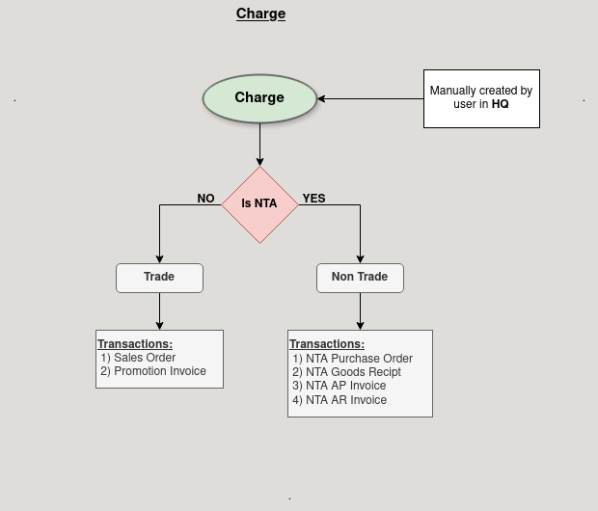

**Business Rules:**

* New charges can only be created in the HQ (Headquarters) system. Users in the HQ are responsible for creating and managing new charges.
* In the HQ, the user must decide if the charge is for NTA by setting the isNTA field to **tick or un-tick**.
* If the isNTA field is set to tick, the charge will be loaded into the HQ system. If the isNTA field is set to un-tick, the charge will remain in the ROW (Regions of the World) system.
* Charges will only be visible and applicable in the respective region (HQ or ROW) based on the isNTA setting, ensuring that charges are correctly assigned to either the Headquarters or the Regions of the World.